



User Manual of
District GIS Parakh Sudden Inspection
For
Onboarded Departments
(Prepared by MPSeDC GIS Department)



Madhya Pradesh State Electronics Development Center (MPS@DC) State IT Center, 47-A, Arera Hills, Bhopal, M.P. – 462011,
Phone: +91-755-2518300,
Fax: +91-755-2579824
URL:www.mpsedc.mp.gov.in

Contents
PARAKH SUDDEN INSPECTION USER MANUAL 3
1. Document Information 3
2. Document Approval 3
3. District GIS Parakh Introduction 3
4. District GIS Parakh Sudden Inspection (Mobile App Flow) 4
4.1 How department users log in to the mobile application 4
4.1.1: Installation 4
4.1.2: Opening the application 4
4.1.3: Providing location permission 5
4.1.4: Select Navigate to point of interest on Map & Route 5
4.1.5: Functionality to do Sudden Inspection 6
4.1.6: Search Destination location to Route through the Map 6
4.1.7: Destination location to Route through the Map 7
4.1.8: Map Route and Projects are Visible for Sudden Inspection 8
4.1.9: Sudden Inspection Survey 9
5. Sign off / Approval 10

PARAKH SUDDEN INSPECTION USER MANUAL

Document Information
Property | Value
Document Title | District GIS Parakh Sudden Inspection - Comprehensive User Manual
Project Name | District GIS Parakh
Developed by | MPSeDC (Madhya Pradesh State e-Governance Data Center)
Document Version | 1.0
Date of Issue | December 4, 2025
Status | Released
Classification | Internal Distribution

Document Approval
Role | Name | Designation | Signature
GIS Head | Rakesh Dubey (Sir) | GIS Head, MPSeDC | ____________
Project Manager | Ajeet Pal SIngh | Data Specialist/PM, MPSeDC | ____________
Senior BA |  |  | ____________
Date

Table 1: Document Approval Matrix

District GIS Parakh Introduction

Parakh is a comprehensive digital solution developed by Madhya Pradesh State Electronics Development Corporation (MPSEDC). It provides different types of input forms, including:
- Data Collection Form
- General Department Form
- General Form for citizen users
- Inspection Form
- Questionnaire Form
- Survey Form
The solution is available as both a web and mobile application. The Parakh application is used by three categories of users:
- Citizen Users
- Department Users
- Agency Users
Citizen users are provided only the General Form. Department users do not use the General Form; instead, they use all other form types such as:
- Data Collection Form
- General Department Form
- Inspection Form
- Survey Form
- Questionnaire Form
Similarly, agency users also do not use the General Form; they use all of the above-mentioned forms.
The purpose of this document is to guide users on how to register in the mobile application and how to submit request forms.​

4. District GIS Parakh Sudden Inspection (Mobile App Flow)

4.1 How department users log in to the mobile application

4.1.1: Installation
- Open the Google Play Store on your mobile device.
- Search for the “Parakh” application or click this link: https://play.google.com/store/apps/details?id=com.mpssdi.parakh
- Tap on the application and select “Install”.
- Wait for the installation process to complete.​

4.1.2: Opening the application
- On your device’s home screen or in the application drawer, locate the “District GIS Parakh” application icon.
- Tap the icon to open the application.​
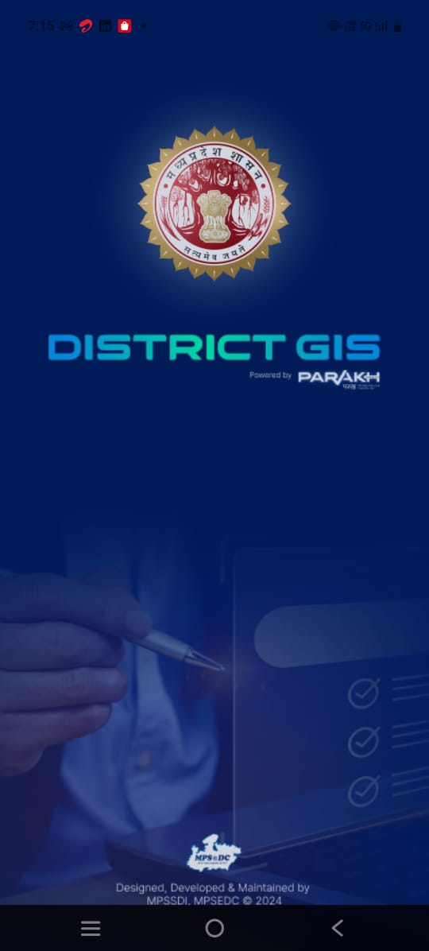

4.1.3: Providing location permission
    - When you open the application for the first time, a prompt may appear asking for permission to access your device’s current location.
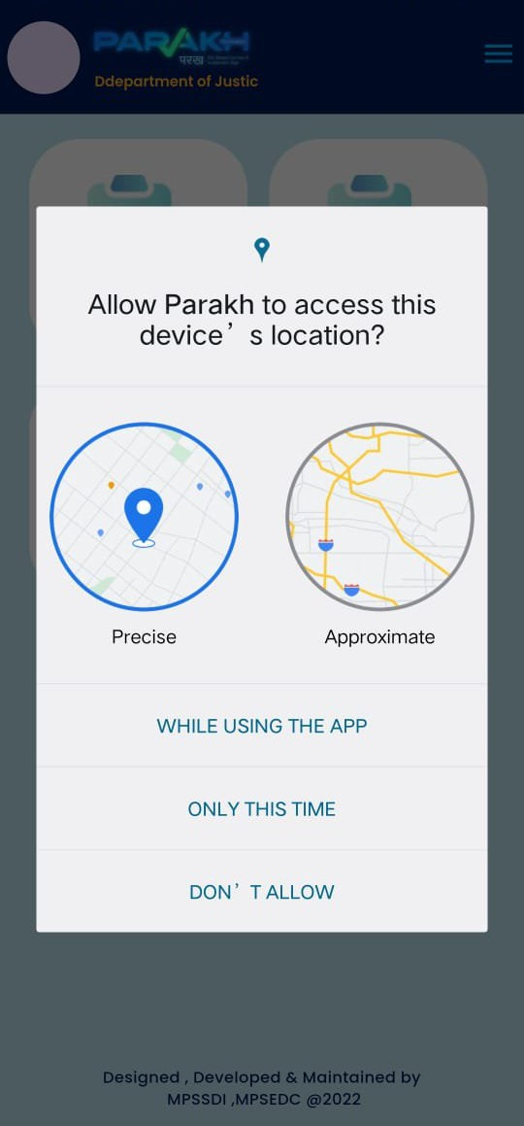
    - Click “Allow” or “Grant permission” to allow the application to access your current location.

4.1.4: Select Navigate to point of interest on Map & Route

- At Home Page of District GIS Parakh App will show “Navigate to point of Interest”.
- Click and Open this option and Map will open.

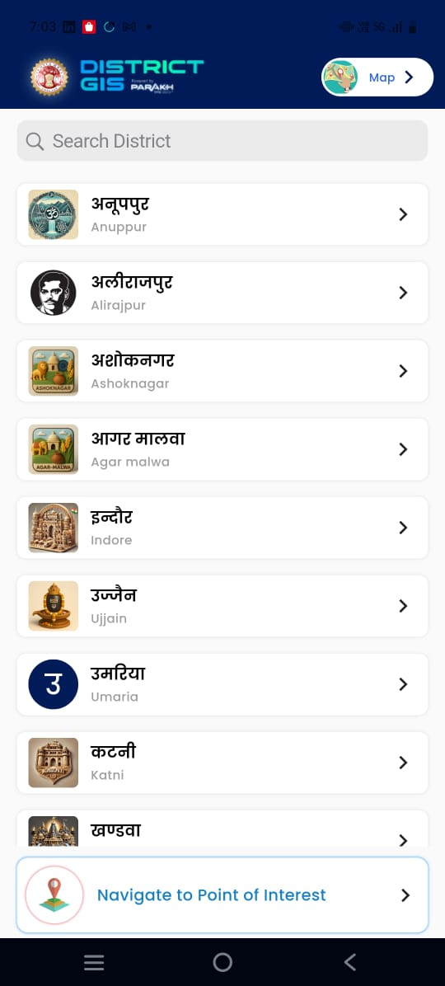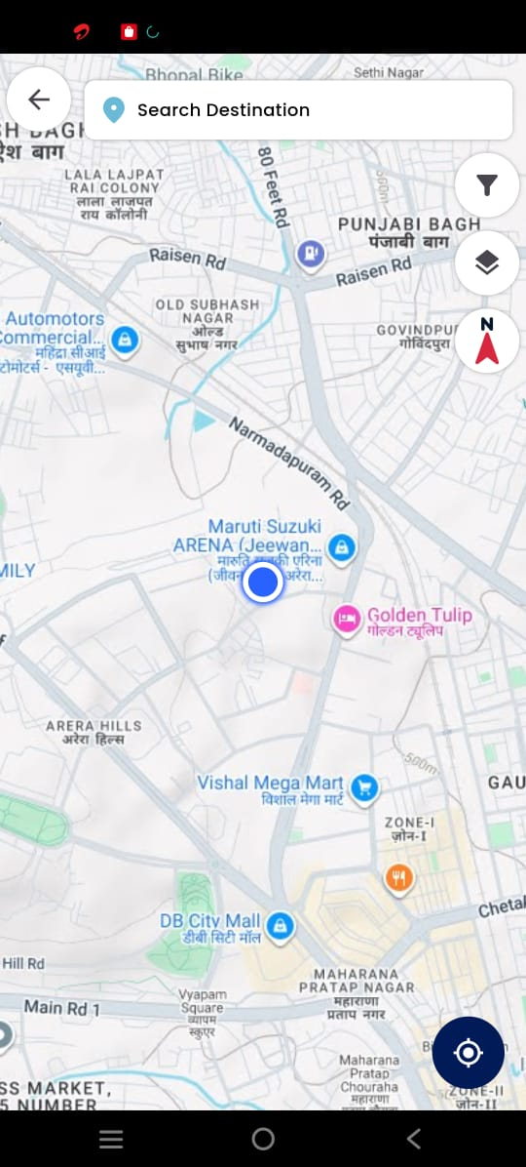

Change Request 09 June 2026

4.1.5: Functionality to do Sudden Inspection
- Once User opens Map, User can perform Inspection of the Asset
- Also, this functionality should be available in Offline Mode & perform Sudden inspection in offline mode.

"On clicking the map, the form should open automatically. Similar to the Asset Mapping functionality, where clicking on the map opens the asset form, the same behavior should be implemented for Sudden Inspection as well."
"Enhancement Required: In the Sudden Inspection module, the form should open automatically when the user clicks on the map, consistent with the existing Asset Mapping functionality."

4.1.6: Search Destination location to Route through the Map

  - Destination location route path will open on the Map.
  - Then Select filter option on Top Right below destination location.

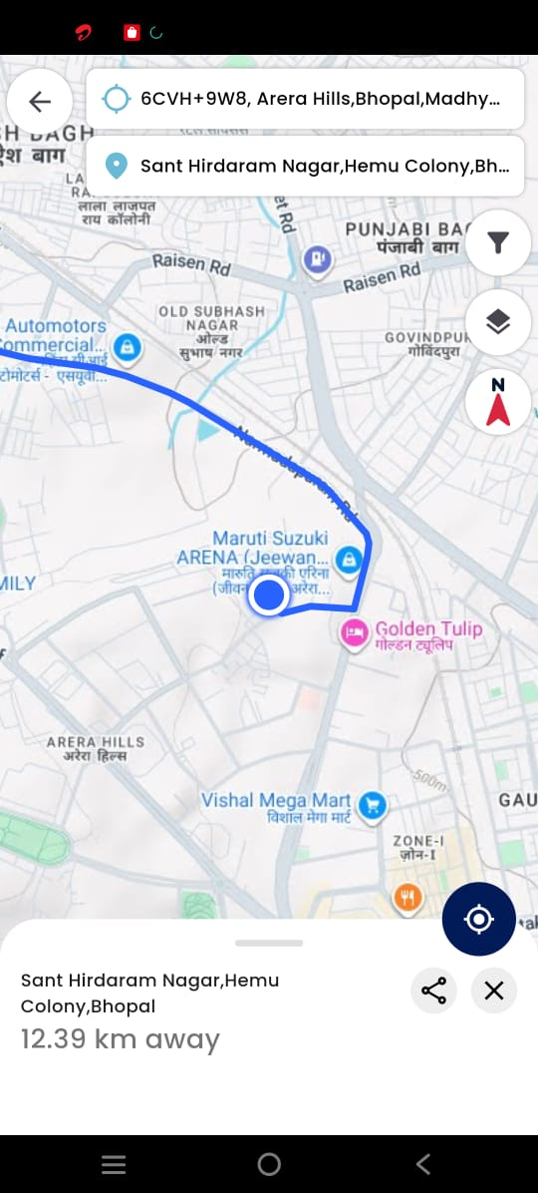

4.1.7: Destination location to Route through the Map

- This Select Filter Option will open below screen and proceed with below options:
  - First Choose, Asset Projects (Running Projects and Other Projects) to be surveyed.
  - Second, Select Buffer range kilometer while routing through the Map path.
  - Sudden Inspection needs to be done for all these Projects which are coming, while routing through the Map path.

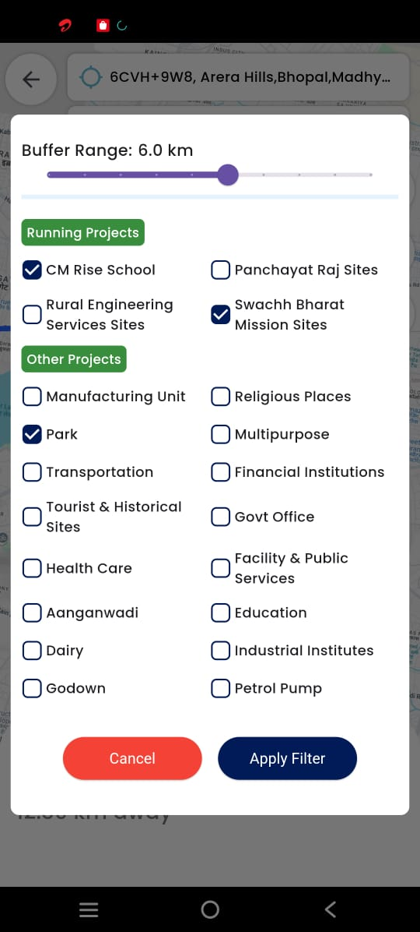

4.1.8: Map Route and Projects are Visible for Sudden Inspection

- Source and Destination route path is visible on map and below that Projects are visible for which Sudden inspection can be conducted by the Department following that buffer range km
- Below this basic details of that projects are mentioned.
- Start Inspection route till that destination location and cover all projects which are coming under that buffer range kilometer.
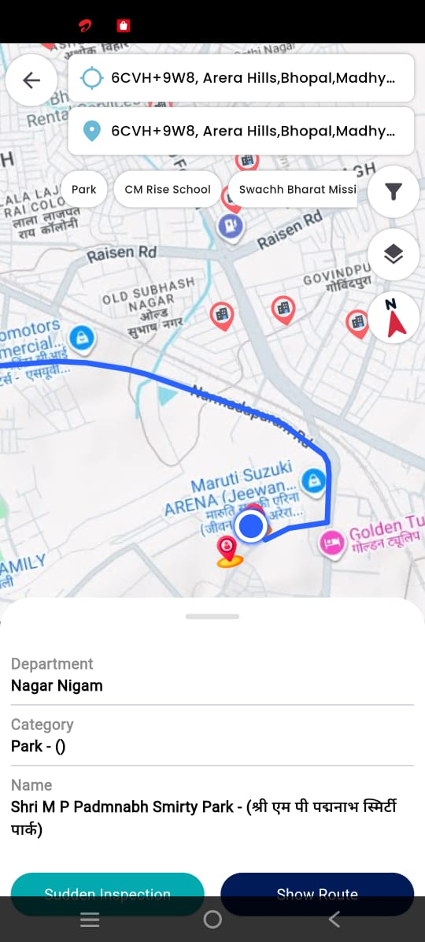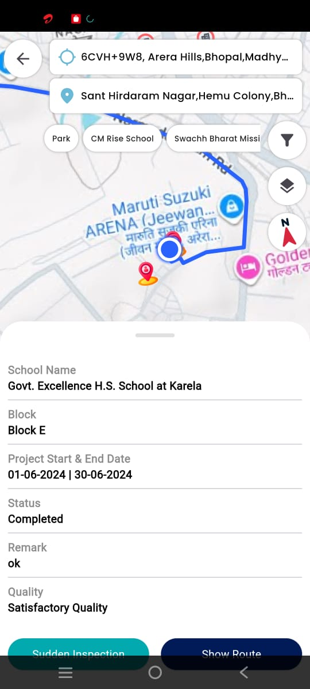

4.1.9: Sudden Inspection Survey

- “Start Inspection” route following “Red Route Path” till that destination location and cover all projects which are coming under that buffer range kilometer.

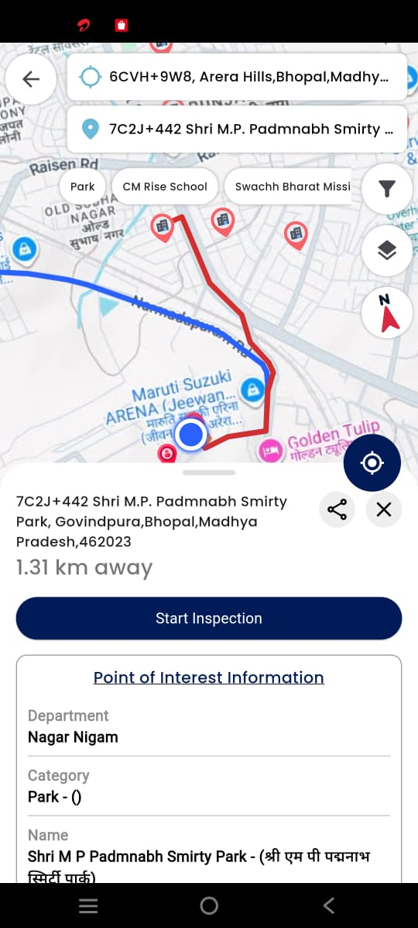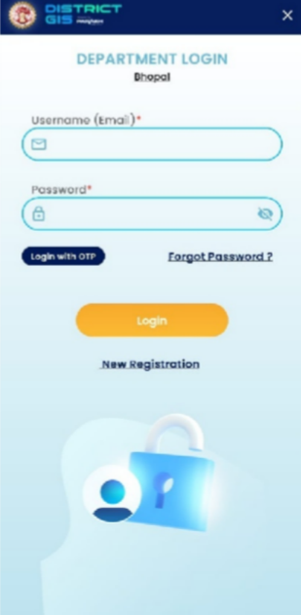

5. Sign off / Approval
I hereby agree and approve that the User Manual of Distirct GIS Parakh Sudden Inspection constitute the complete end to end flow of Sudden Inpsection. After approval, any additions and changes to this document or referred objects will be pursued through the change request process.

For Department
Name
Approved By
Designation
Organization
Signature with Seal
Date

